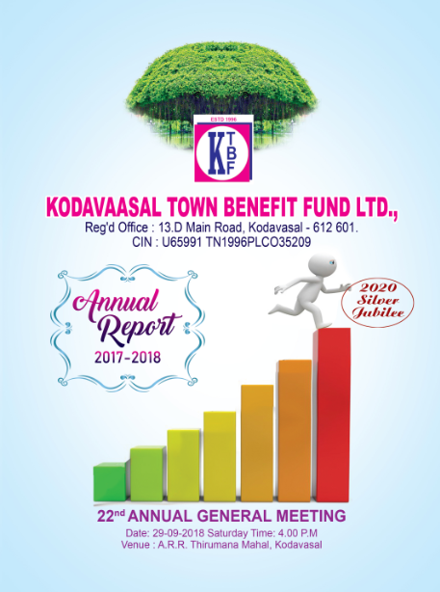



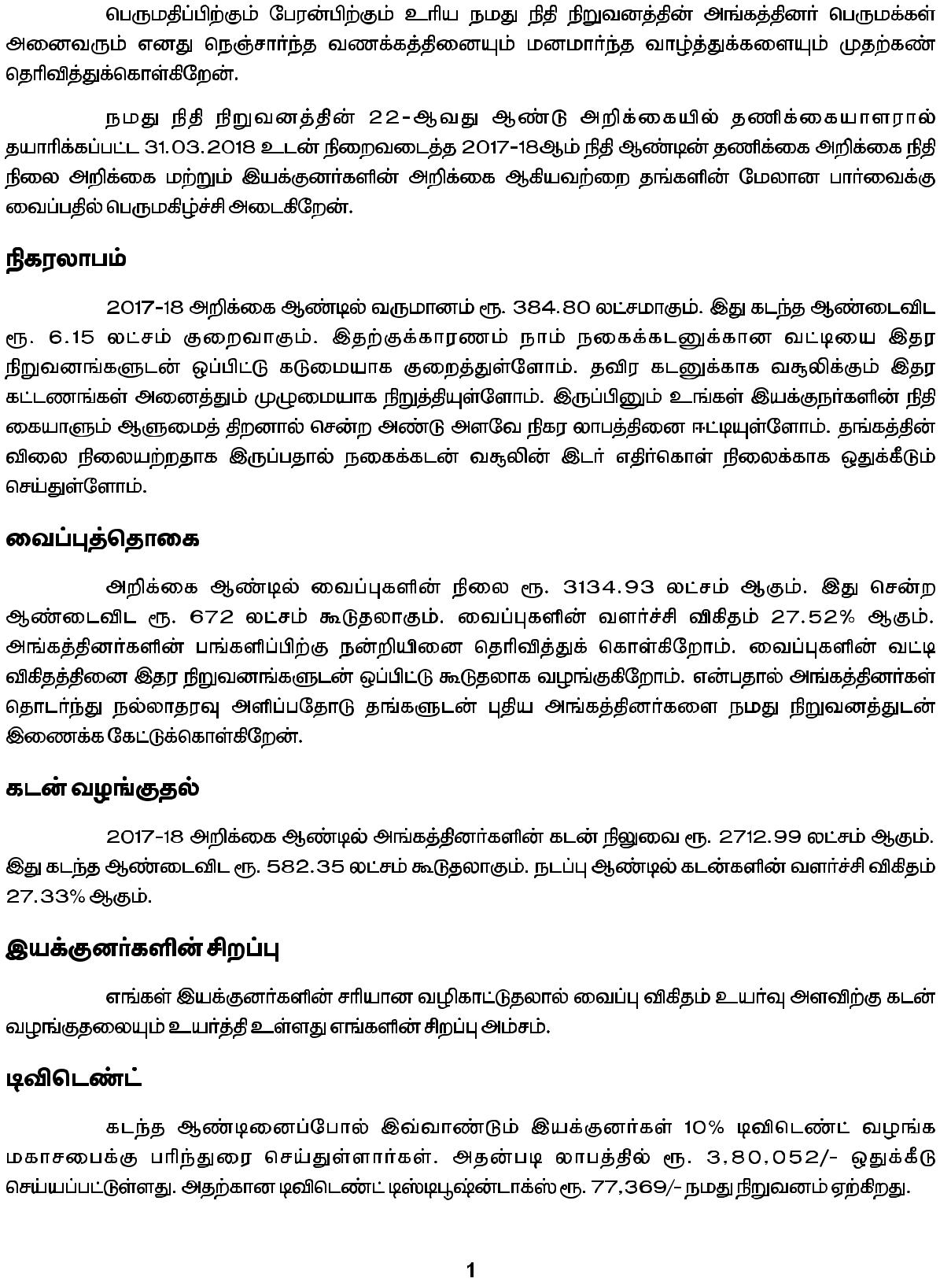



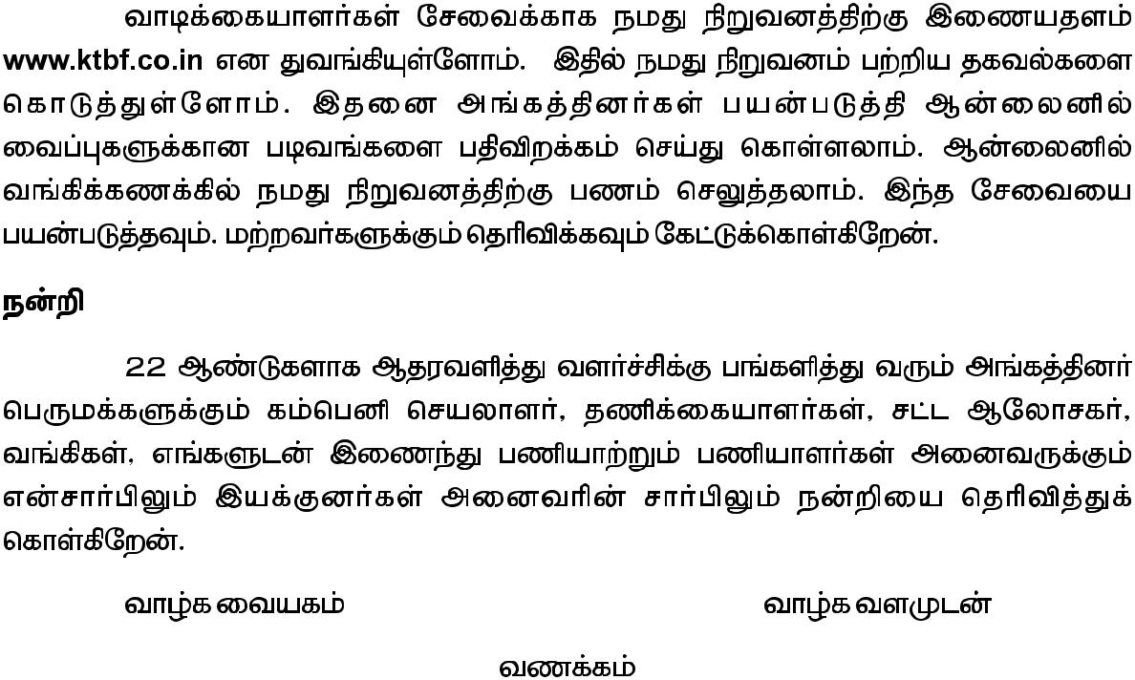







**NOTICE**

Notice is hereby given pursuant to Section 96 and other applicable provisions of the Companies Act, 2013 that the 22ndAnnual General Meeting of the shareholders of the Company relating to the financial year ended 31-03-2018 is scheduled to be held on Saturday, the 29th September, 2018 at 4.00 P.M. at A.R.R Thirumana Mahal, Thirukkulam Southbank, Kodavasal to transact the following business:

**ORDINARY BUSINESS**

1. **To adopt Accounts**

To receive, consider and adopt the Audited Financial Statements of the Company for the year ended on 31st March, 2018 and the connected schedules, notes together with the reports of the Directors and Auditors thereon.

1. **To declare Dividend**

The Directors of the Company recommends dividend @ 10% for the financial year ended 31-03-2018

1. **To elect Directors**

Mrs. S. Malarvizhi (DIN: 06437133), Mrs. V. Ponarasi (DIN: 02591628), Mr. S. Mohanakrishnan (DIN: 07440234) and Mr. S. Ramamoorthy (DIN: 07443612), Directors of the Company retire by rotation and being eligible offer themselves for

re-appointment.

By order of the Board

Place : Kodavasal Dr. K. Balakumaravelu

Date : 14-08-2018 Chairman

**Notes:**

1. A member entitled to attend and vote at the Annual General Meeting is entitled to appoint a proxy to attend and vote on a poll instead of himself and the proxy need not be a member of the Company. The instrument appointing the proxy should, however, be deposited at the Registered Office of the Company not less than forty-eight hours before the commencement of the Meeting.
2. Members are requested to bring their attendance slip along with their copy of Annual Report to the Meeting.
3. Members are requested to notify change of address, if any, to the registered office of the Company.
4. Members whose name appears as on the date of the Annual General Meeting (‘Record Date’) shall be eligible for payment of Dividend subject to approval of the Members for payment of Dividend at the ensuing Annual General Meeting.

**DIRECTORS’ REPORT**

Your Directors have great pleasure in presenting the 22ndAnnual Report and Audited Accounts relating to the financial year ended 31st March 2018 pursuant to Section 134 and other applicable provisions of the Companies Act, 2013. This report has been given by covering all the points which are applicable to our Company under the provisions of the Companies Act, 2013 and the applicable Rules

1. **Financial Highlights**

During the year under review, performance of your company has been given in a nutshell as under:

(Amount in Rs.)

|  |  |  |
| --- | --- | --- |
| **Particulars** | **For the year ended**  **31-03-2018** | **For the year ended**  **31-03-2017** |
| Revenue from Operation  Other Income | 3,66,94,370  17,85,677 | 3,81,57,746  9,37,344 |
| Gross Income | 3,84,80,047 | 3,90,95,090 |
| Total Expenditure | 3,50,33,688 | 3,50,42,751 |
| Profit Before Tax | 34,46,359 | 40,52,339 |
| Less: Tax Expense | 8,59,568 | 8,16,942 |
| Profit after Tax  (+) Surplus brought forward from P.Y  IT Refund  (-) Appropriations   * Transfer to General reserve * Proposed Equity Dividend * Tax on proposed Equity Dividend * P.Y. Income Tax short provision | 25,86,791  29,96,088  64,736  5,00,000  3,80,052  77,369  ------- | 32,35,397  46,73,065  9,00,000  3,77,762  76,903  35,57,709 |
| **Balance in Surplus** | **46,90,194** | **29,96,088** |

1. **Meetings of the Board and Committee**

The Board meets regularly to discuss and decide on various matters as required. During the year, 13 Board Meetings were convened and held. The dates of Meeting and the details of Directors attended the Meeting are given as Annexure-1.

**Executive Committee:**9 Executive Committee Meetings were convened and held. The dates of Meeting and the details of Directors attended the Meeting are given in Annexure-1.This Executive Committee is a non-mandatory committee constituted for getting the experts advise and operational convenience for running the business of the Company.

1. **State of company’s affairs and future outlook, business risks, internal audits and internal controls**

As can be seen from the audited Profit and Loss Account, the business of the Company has shown slight decrease due to competition from the organized Banking sector as well as unorganized Pawn brokers. All efforts are taken to overcome the constraints by taking concerted efforts to improve business through our branches opened at village levels. We have 8 branches as on the date of this report. We got permission to open branches at Erode, Thanjavur, Thiruvarambur, Manaparai and Chennai. We advance loans by strictly following the rules and regulations laid down by RBI mainly against Jewels and rarely against fixed deposits kept with us. No material changes have occurred between the Balance Sheet date and the date of this report for being reported to the shareholders.

Regarding Risk Management Policy, your Board brings to the notice of the shareholders that just like in any other business our business also entails certain risks such as possibilities of hypothecation of spurious jewels, volatility in market price of gold leading to non-recovery of loans etc., Your directors are taking utmost care by appraising each and every jewel, re-verifying the jewels, bringing to auction the jewels which remain unredeemed by the owners of the jewels in time etc.,

The Company has proper internal controls, security systems to protect the properties and business of the company. The Company has not suffered loss by way of bad debts during the year under report.

1. **Dividend**

Your directors are pleased to recommend dividend at 10% which absorbs a sum of Rs3,80,052/- The dividend distribution tax payable by the company amounts to Rs.77,369/-

1. **Reserves and Share Capital**

Your directors have transferred a sum of Rs.5, 00,000/- to General Reserves for the year ended 31-03-2018. The Reserves and Surplus as on 31st March 2018 stands at Rs.1,75,04,681/-(Previous year is Rs.1,53,10,575/-). The Paid-up capital of the Company as on 31st March 2018 is Rs.40, 66,579/-(As on 31st March 2017Rs.40, 25,269/-)

1. **Extract of Annual Return**

The extract of Annual Return, in format MGT-9, for the Financial Year 2017-18 is annexed to this report as Annexure-2*.*

1. **Particulars of Loan, Guarantees and Investments Under Section 186**

The main business of the company is to lend money only to the members of the company against jewels. The lending business is strictly carried out as per the rules and regulations laid down for NIDHI Companies under the Provisions of the Companies Act, 2013 and RBI Regulations. No loan or guarantee is given to any corporate bodies or non-members of the company.

1. **Particulars of contracts or arrangements with related parties**

There are no materially significant related party transactions made by the Company which may have a potential conflict with the interest of the Company. Particulars of contract(s) and arrangement(s) with Related Parties are appended in Form AOC-2 forming part of this report as Annexure-3.All the aforesaid related party transaction(s)are at an arm’s length basis and are in the ordinary course of business.

1. **Explanation to Auditors’ remarks**

The Auditors have not given any adverse remarks for being explained by the Board

1. **Conservation of Energy, Technology, Absorption, Foreign Exchange Earnings and Outgo**

Your company is carrying out non-banking business activity and hence there is no special report to be given by us. All efforts are taken to conserve energy. There was no foreign exchange inflow or outflow during the financial under report.

1. **Directors**

Mrs. S. Malarvizhi, Mrs. V. Ponarasi, Mr. S. Mohanakrishnan and Mr. S. Ramamoorthyretire by rotation and being eligible they offer themselves for re-election. The Board recommends tore-elect them. The remuneration / sitting fees paid to the Directors forms part of annexure (MGT-9) to this report. There was no change in the constitution of the Board during the year.

1. **Particulars of Employees**

None of the employees of the Company drew remuneration in excess of the limits specified under Rule 5(2)(i) and (ii) of the Companies (Appointment and Remuneration) Rules, 2014.

1. **Deposits**

Being a Nidhi Company, the provisions of Section 73 to 76 of the Companies Act, 2013 and Companies (Acceptance of Deposits) Rules, 2014 are not applicable to the Company.

The Company is accepting deposits only from members strictly within the norms ie., within twenty times the paid-up capital and free reserves as per the norms laid down for NIDHI Companies. The details of deposits are given hereunder:

(in Rs.)

|  |  |  |
| --- | --- | --- |
| **Particulars** | **Figures relating to 2017-18** | **Figures relating to 2016-17** |
| Opening Deposit | 24,62,24,437 | 26,99,12,901 |
| Deposits accepted during the year | 69,50,83,120 | 41,24,58,059 |
| Deposits repaid during the year | 62,78,14,251 | 43,61,46,523 |
| Deposits at the end of the year | 31,34,93,307 | 24,62,24,437 |
| Unclaimed Deposits | NIL | NIL |
| Unpaid Deposits | NIL | NIL |

There was no default or delay in repayment of deposit or payment of interest.The Company is always keeping not less than 10% of the deposit in unencumbered securities as laid down in the rules and regulations laid down for NIDHI Companies.The growth of deposit over last year is 27.32%

**Loan to Members:** The loan issued to members during the year and outstanding as at 31-03-2018 is Rs.27,12,99,067 as against the last year figure of Rs.21,30,64,375.The growth in loans issue over last year is27.33%

The total number of members as on the date of this report is 31,575, out of which the number of members holding Equity shares worth Rs.1,000/- or more is 650. As per the Notification of the Ministry of Corporate Affairs dated 5th June 2015, NIDHI Companies need to send the Annual Report and Accounts only to members who hold shares of more than one thousand rupees in face value or more than one per cent of the total paid-up share capital of the Nidhi whichever is less.

For other shareholders, document may be served by a public notice in newspaper circulated in the district where the Registered Office of the Nidhi is situated; and publication of the same on the notice board of the Nidhi. Your Company abides by the notification.

1. **Details of Significant and Material Orders**

There are no significant or material orders passed by the Regulators or Courts or Tribunals impacting the going concern status and Company’s operations in future.

1. **Statutory Auditor**

Mr.S.Govindarajan, Chartered Accountant, Kumbakonam [Membership No. 212285], was appointed at the AGM held on 29-09-2016, for a period of five years ie.,upto the financial year ending on 31-03-2021. The Auditor has discharged the assigned duties. Ratification of appointment of Auditor at the Annual General Meeting has been done away with pursuant to the provisions of the Companies Amendment Act, 2017.

1. **Policy against sexual harassment at the workplace**

During the F.Y. 2017-18, the Company has a system to prevent, enquire and take disciplinary action against employees committing sexual harassment to woman employees at the workplace. All types of employees are covered under this system. The Company has not received any complaints during the year under review.

1. **Corporate Social Responsibility**

The provisions of Corporate Social Responsibility does not apply to the Company as the Profit (PBT) is less than Rs.5.00 Crores or the net worth is less than Rs.500.00 Crores or the turnover is less than Rs.1,000.00 Crores during the preceding financial year as prescribed under Section 135 of the Companies Act, 2013.

1. **Secretarial Standards**

Applicable Secretarial Standards, i.e. SS-1 and SS-2, relating to ‘Meetings of the Board of Directors’ and ‘General Meetings’, respectively, have been duly complied with by the Company.

1. **Disclosure on Section 148 of the Companies Act, 2013**

The Company is a NIDHI Company and hence the provisions of Section 148 of the Companies Act, 2013 with respect to maintenance of cost records are not applicable to the Company.

1. **Directors’ Responsibility Statement**

In accordance with the provisions of Section 134(5) of the Companies Act 2013, your directors confirm that:

1. in the preparation of the annual accounts for the financial year ended 31st March, 2018, the applicable accounting standards had been followed along with proper explanation relating to material departures;
2. the directors had selected such accounting policies and applied them consistently and made judgments and estimates that are reasonable and prudent so as to give a true and fair view of the state of affairs of the Company as at 31st March, 2018 and of the Profits of the Company for that period;
3. the directors had taken proper and sufficient care for the maintenance of adequate accounting records in accordance with the provisions of the Companies Act 2013 for safeguarding the assets of the company and for preventing and detecting fraud and other irregularities;
4. the directors had prepared the annual accounts on a going concern basis;
5. the directors had devised proper systems to ensure compliance with the provisions of all applicable laws and that such systems were adequate and operating effectively.
6. the directors had laid down internal financial controls to be followed by the company and that such internal financial controls are adequate and were operating effectively.
7. **Acknowledgment**

The Directors express their sincere appreciation to the valued shareholders, government agencies, bankers’,employees and clients for their support.

For and on behalf of the Board

Dr. K. Balakumaravelu

Chairman

Place : Kodavasal

Date : 14-08-2018

**Annexure – 1**

* 1. **Dates of Board Meeting and the details of Directors attended the Board Meeting**

|  |  |  |
| --- | --- | --- |
| Sl. No. | Date of Board Meeting | Name of Directors attended the Meeting |
| 1. | 12-04-2017 | All the Directors of the Company viz., Dr. K. Balakumaravaelu, Mr. S. Santhanakrishnan, Mr. S. Ramamoorthy, Mr. S. Aranganathan, Mr. A. Kajahusain, Mr. S. Mohanakrishnan, Mrs. P.L. Kamalam, Mrs. V. Shanthi, Mrs. V. Ponnarasi, Mr. B. Senthil and Mrs. S. Malarvizhi have attended all the Board Meetings held during the year. |
| 2. | 10-05-2017 |
| 3. | 13-06-2017 |
| 4. | 20-07-2017 |
| 5. | 05-08-2017 |
| 6. | 04-09-2017 |
| 7. | 07-10-2017 |
| 8. | 09-11-2017 |
| 9. | 08-12-2017 |
| 10. | 10-01-2018 |
| 11. | 08-02-2018 |
| 12. | 12-03-2018 |
| 13. | 31-03-2018 |

* 1. **Dates of Executive Committee Meeting and the details of Members attended the Committee Meeting**

|  |  |  |
| --- | --- | --- |
| Sl. No. | Date of Executive Committee Meeting | Name of Members attended the Meeting |
| 1. | 28-04-2017 | All the Executive Committee Members viz., Dr. K. Balakumaravaelu, Mr. S. Santhanakrishnan, Mr. S. Mohanakrishnan and Mr. S. Aranganathan, have attended all the Executive Committee Meetings held during the year |
| 2. | 31-05-2017 |
| 3. | 30-06-2017 |
| 4. | 31-07-2017 |
| 5. | 30-08-2017 |
| 6. | 27-09-2017 |
| 7. | 21-10-2017 |
| 8. | 23-11-2017 |
| 9. | 28-12-2017 |

For and on behalf of the Board

Dr. K. Balakumaravelu

Chairman

Place : Kodavasal

Date : 14-08-2018

**ANNEXURE – 2**

**Form MGT-9EXTRACT OF ANNUAL RETURN**

As on the financial year ended on 31st March, 2018

*[Pursuant to Section 92(3) and 134(3)(a) of the Companies Act, 2013 and Rule 12(1) of theCompanies (Management and Administration) Rules]*

1. **REGISTRATION AND OTHER DETAILS**:

|  |  |  |
| --- | --- | --- |
| i. | CIN | U65991TN1996PLC035209 |
| ii. | Registration Date | 16-04-1996 |
| iii. | Name of the Company | Kodavaasal Town Benefit Fund Limited |
| iv. | Category / Sub-Category of the Company | Public Company (Nidhi)/ Limited by Shares |
| v. | Address of the Registered office and contact details | 13/T,Bazar Street, Kodavasal Nagai Kayide Milleth District – 612 601 |
| vi. | Whether listed Company | No |
| vii. | Name, Address and Contact details of Registrar and Transfer Agent, if any | N.A |

1. **PRINCIPAL BUSINESS ACTIVITIES OF THE COMPANY**

All the business activities contributing 10% or more of the total turnover of the company shall bestated

|  |  |  |  |
| --- | --- | --- | --- |
| **Sl. No.** | **Name and Description of main Products/ Services** | **NIC Code of the Products/ Services** | **% to total turnover of the Company** |
| 1. | Non-Banking Business - Nidhi |  | 100.00 |

1. **PARTICULARS OF HOLDING, SUBSIDIARY AND ASSOCIATE COMPANIES**

|  |  |  |  |  |  |
| --- | --- | --- | --- | --- | --- |
| **Sl. No.** | **Name and Address of the Company** | **CIN/ GLN** | **Holding/ Subsidiary**  **/Associate** | **% of shares held** | **Applicable**  **Section** |
| Nil | | | | | |

1. **SHARE HOLDING PATTERN (Equity Share Capital Breakup as percentage of Total Equity)**
2. **Category-wise Share Holding**

|  |  |  |  |  |  |  |  |
| --- | --- | --- | --- | --- | --- | --- | --- |
| **Category of**  **Shareholders** | **No. of Shares held at the beginning of the year** | | | **No. of Shares held at the end of the year** | | | **% of change duringthe year** |
| Physical | Total | % of Total Shares | Physical | Total | % of Total Shares |
| 1. Promoters 2. Indian 3. Individual/HUF | 596400 | 596400 | 14.82 | 596400 | 596400 | 14.67 | (0.15) |
| Sub-Total A (1) | **596400** | **596400** | **14.82** | **596400** | **596400** | **14.67** | **(0.15)** |
| 1. Foreign | **-** | **-** | **-** | **-** | **-** | **-** | **-** |
| Sub-Total A (2) | - | - | - | - | - | - | - |
| Total share holding of Promoter (A) = (A) (1) + (A) (2) | **596400** | **596400** | **14.82** | **596400** | **596400** | **14.67** | **(0.15)** |

|  |  |  |  |  |  |  |  |
| --- | --- | --- | --- | --- | --- | --- | --- |
| 1. Public Share holding    * + 1. Institutions | - | - | - | - | - | - | - |
| Sub-Total B (1) | - | - | - | - | - | - | - |
| * + - 1. Non-Institutions   Individuals   1. Individual share holders holding nominal share capital upto Rs.1 Lakh 2. Individual share holders holding nominal share capital in excess of Rs.1 Lakh | 2844869  584000 | 2844869  584000 | 70.67  14.51 | 2886179  584000 | 2886179  584000 | 70.97  14.36 | 0.30  (0.15) |
| Sub-Total B (2) | **3428869** | **3428869** | **85.18** | **3470179** | **3470179** | **85.33** | **0.15** |
| Total Public Share holding (B) = (B) (1) + (B) (2) | **3428869** | **3428869** | **85.18** | **3470179** | **3470179** | **85.33** | **0.15** |
| 1. Shares held by Custodian for GDRs & ADRs | - | - | - | - | - | - | - |
| **GRAND TOTAL (A+B+C)** | **4025269** | **4025269** | **100%** | **4066579** | **4066579** | **100%** | **-** |

Note: All the shares of the Company are held by the shareholders in physical form only.

1. **Shareholding of Promoters**

|  |  |  |  |  |  |  |  |  |
| --- | --- | --- | --- | --- | --- | --- | --- | --- |
| **Sl. No.** | Shareholder’s Name | Shareholding at the beginning of the year | | | Shareholding at the end of the year | | | % change in share holding during the year |
| No. of Shares | % of total shares of the Company | %of Shares Pledged / encumbered to total shares | No. of Shares | % of total shares of the Company | %of Shares Pledged / encumbered to total shares |
| 1 | K.Balakumaravelu | 94500 | 2.35 | - | 94500 | 2.32 | - | (0.03) |
| 2 | S.Aranganathan | 66000 | 1.64 | - | 66000 | 1.62 | - | (0.02) |
| 3 | Kr.Vijayarengan | 85300 | 2.12 | - | 85300 | 2.10 | - | (0.02) |
| 4 | V.Shanthi | 85300 | 2.12 | - | 85300 | 2.10 | - | (0.02) |
| 5 | S.Dhanalakshmi | 40500 | 1.00 | - | 40500 | 1.00 | - | - |
| 6 | S.Mohanakrishnan | 54300 | 1.35 | - | 54300 | 1.34 | - | (0.01) |
| 7 | B.Balakrishnan | 76000 | 1.89 | - | 76000 | 1.87 | - | (0.02) |
| 8 | A.Kaja Husain | 33000 | 0.82 | - | 33000 | 0.81 | - | (0.01) |
| 9 | S.Ramamoorthy | 61500 | 1.53 | - | 61500 | 1.51 | - | (0.02) |
| **TOTAL** | | **596400** | **14.82** | - | **596400** | **14.67** | **-** | (0.15) |

1. **Change in Promoters’ Shareholding (please specify, if there is no change)** : Nil

The changes in the percentage of shareholding of Promoters are due to allotment of shares to new members of the Company as per Companies (Nidhi) Rules, 2014 during the year.

1. **Shareholding Pattern of top ten Shareholders (other than Directors, Promoters and Holders of GDRs and ADRs)**

|  |  |  |  |  |  |  |  |  |
| --- | --- | --- | --- | --- | --- | --- | --- | --- |
| Sl. No. | Name | Shareholding at the beginning of the year | | | | Cumulative Shareholding during the year | | At the end of the year |
| No. of shares | % of total shares of the Company | Date wise  increase /  decrease in  shareholding  during the  year | Reasons for increase / decrease | No. of shares | % of total shares of the Company |
| 1. | S.Gopalakrishnan | 132000 | 3.28 | - | - | 132000 | 3.25 | 132000 |
| 2. | K.G.Susindran | 124000 | 3.08 | - | - | 124000 | 3.05 | 124000 |
| 3. | S.Brindha | 109500 | 2.72 | - | - | 109500 | 2.69 | 109500 |
| 4. | Pl.Annamalai | 102700 | 2.55 | - | - | 102700 | 2.53 | 102700 |
| 5. | M.Uppilivenkatragavan | 94000 | 2.34 | - | - | 94000 | 2.31 | 94000 |
| 6. | V.Rajendran | 50000 | 1.24 | - | - | 50000 | 1.23 | 50000 |
| 7. | S.Thamaraiselvi | 50000 | 1.24 | - | - | 50000 | 1.23 | 50000 |
| 8. | K.Arumugam | 30000 | 0.75 | - | - | 30000 | 0.74 | 30000 |
| 9. | K.Krishnasamy | 20000 | 0.50 | - | - | 20000 | 0.49 | 20000 |
| 10. | V.Kunjithapatham | 20000 | 0.50 | - | - | 20000 | 0.49 | 20000 |
| **TOTAL** | | **732200** | **18.20** | **-** | **-** | **732200** | **18.01** | **732200** |

The changes in the percentage of shareholding of top ten shareholders are due to allotment of shares to new members of the Company as per Companies (Nidhi) Rules, 2014 during the year.

1. **Shareholding of Directors and Key Managerial Personnel**

|  |  |  |  |  |  |  |  |  |
| --- | --- | --- | --- | --- | --- | --- | --- | --- |
| Sl. No. | Name | Shareholding at the beginning of the year | | | | Cumulative Shareholding during the year | | At the end of the year |
| No. of shares | % of total shares of the Company | Date wise  increase /  decrease in  shareholding  during the  year | Reasons for increase / decrease | No. of shares | % of total shares of the Company |
| 1. | K.Balakumaravelu | 94500 | 2.35 | - | - | 94500 | 2.32 | 94500 |
| 2. | S.Ramamoorthy | 61500 | 1.53 | - | - | 61500 | 1.51 | 61500 |
| 3. | S.Santhanakrishnan | 50000 | 1.24 | - | - | 50000 | 1.23 | 50000 |
| 4. | V.Ponarasi | 56500 | 1.40 | - | - | 56500 | 2.13 | 56500 |
| 5. | S.Mohanakrishnan | 54300 | 1.35 | - | - | 54300 | 1.34 | 54300 |
| 6. | S.Aranganathan | 66000 | 1.64 | - | - | 66000 | 1.62 | 66000 |
| 7. | B.Senthil | 43000 | 1.07 | - | - | 43000 | 1.06 | 43000 |
| 8. | V.Shanthi | 85300 | 2.12 | - | - | 85300 | 2.10 | 85300 |
| 9. | A.Kajahusain | 33000 | 0.82 | - | - | 33000 | 0.81 | 33000 |
| 10. | S.Malarvizhi | 60550 | 1.50 | - | - | 60550 | 1.49 | 60550 |
| 11. | Pl.Kamalam | 97600 | 2.42 | - | - | 97600 | 2.40 | 97600 |
| **TOTAL** | | **702250** | **17.45** | **-** | **-** | **702250** | **17.27** | **702250** |

The changes in the percentage of shareholding of Directors are due to allotment of shares to new members of the Company as per Companies (Nidhi) Rules, 2014 during the year.

1. **INDEBTEDNESS**

**Indebtedness of the Company including interest outstanding/accrued but not due for payment (in Rs.)**

|  |  |  |  |  |
| --- | --- | --- | --- | --- |
|  | Secured Loans excluding Deposits | Unsecured Loans | Deposits | Total Indebtedness |
| Indebtedness at the beginning of the financial year   1. Principal Amount 2. Interest due but not paid 3. Interest accrued but not due | - | - | 24,62,24,438  1,47,68,012 | 24,62,24,438  1,47,68,012 |
| **Total (i) + (ii) + (iii)** | **-** | **-** | **26,09,92,450** | **26,09,92,450** |
| Change in Indebtedness during the financial year   1. Addition 2. Reduction | -  - | -  - | 69,50,83,120  62,78,14,251 | 69,50,83,120  62,78,14,251 |
| **Net Change** | **-** | **-** | **6,72,68,869** | **6,72,68,869** |
| Indebtedness at the end of the financial year   1. Principal Amount 2. Interest due but not paid 3. Interest accrued but not due | - | - | 31,34,93,307  1,21,72,056 | 31,34,93,307  1,21,72,056 |
| **Total (i) + (ii) + (iii)** | **-** | **-** | **32,56,65,363** | **32,56,65,363** |

1. **REMUNERATION OF DIRECTORS AND KEY MANAGERIAL PERSONNEL**
2. Remuneration to Director, Managing Director, Whole-time Directors : Nil
3. Remuneration to other Directors(Sitting Fees for attending Board/ Committee Meetings) : Refer list given below
4. Remuneration to Key Managerial Personnel (CEO/ Company Secretary/ CFO) other than MD/Manager/WTD : Nil
5. **PENALTIES / PUNISHMENT/ COMPOUNDING OF OFFENCES – COMPANY, DIRECTORS AND OTHER OFFICERS IN DEFAULT**

|  |  |  |  |  |  |
| --- | --- | --- | --- | --- | --- |
| **Type** | **Section of the Companies Act** | **Brief Description** | **Details of Penalty / Punishment/ Compounding fees imposed** | **Authority [RD / NCLT/ COURT]** | **Appeal made, if any (Give Details)** |
| Penalty | N.A. | N.A. | N.A. | N.A. | N.A. |
| Punishment | N.A. | N.A. | N.A. | N.A. | N.A. |
| Compounding | N.A. | N.A. | N.A. | N.A. | N.A. |

For and on behalf of the Board

Dr. K. Balakumaravelu

Chairman

Place : Kodavasal

Date : 14-08-2018

**REMUNERATION OF DIRECTORS DURING 01-04-2017 TO 31-03-2018**

|  |  |  |  |  |
| --- | --- | --- | --- | --- |
| **Sl. No.** | **Name of the Director** | **(Amount in Rs.)** | | |
| **Remuneration** | **Sitting Fees** | |
| **Board Meeting** | **Committee Meeting** |
| 1. | Dr. K. Balakumaravelu | NIL | 2,10,000 | 96,000 |
| 2. | Mrs. PL. Kamalam | 2,10,000 | - |
| 3. | Mrs. V. Shanthi | 2,10,000 | - |
| 4. | Mrs. S. Malarvizhi | 2,10,000 | - |
| 5. | Mr. S. Santhanakrishnan | 2,10,000 | 66,000 |
| 6. | Mr. B. Senthil | 2,10,000 | - |
| 7. | Mrs. V. Ponarasi | 2,10,000 | - |
| 8. | Mr. S. Mohanakrishnan | 2,10,000 | 66,000 |
| 9. | Mr. S. Aranganathan | 2,10,000 | 66,000 |
| 10. | Mr. A. Khaja Husain | 2,10,000 | - |
| 11. | Mr. S. Ramamoorthy | 2,10,000 | - |
| **TOTAL** | | **NIL** | **23,10,000** | **2,94,000** |
| **GRAND TOTAL** | | **NIL** | **26,04,000** | |

For and on behalf of the Board

Dr. K. Balakumaravelu

Chairman

Place : Kodavasal

Date : 14-08-2018

